In this lab you will use the World Wide Telescope, a free telescope simulation developed by Microsoft, now supported by the American Astronomical Society, in which you can observe close up images from basically every survey that has been done to date. It is completely web based (though you can download versions for PC and Mac), so it should be accessible by everyone. You should not leave an astronomy course without having a chance to play with it!

Part 1: Learning to use the World Wide Telescope

1. Go to this url: https://worldwidetelescope.org/webclient/
Read the tips on the welcome screen, and then close it. You will have an opening screen that looks like this:
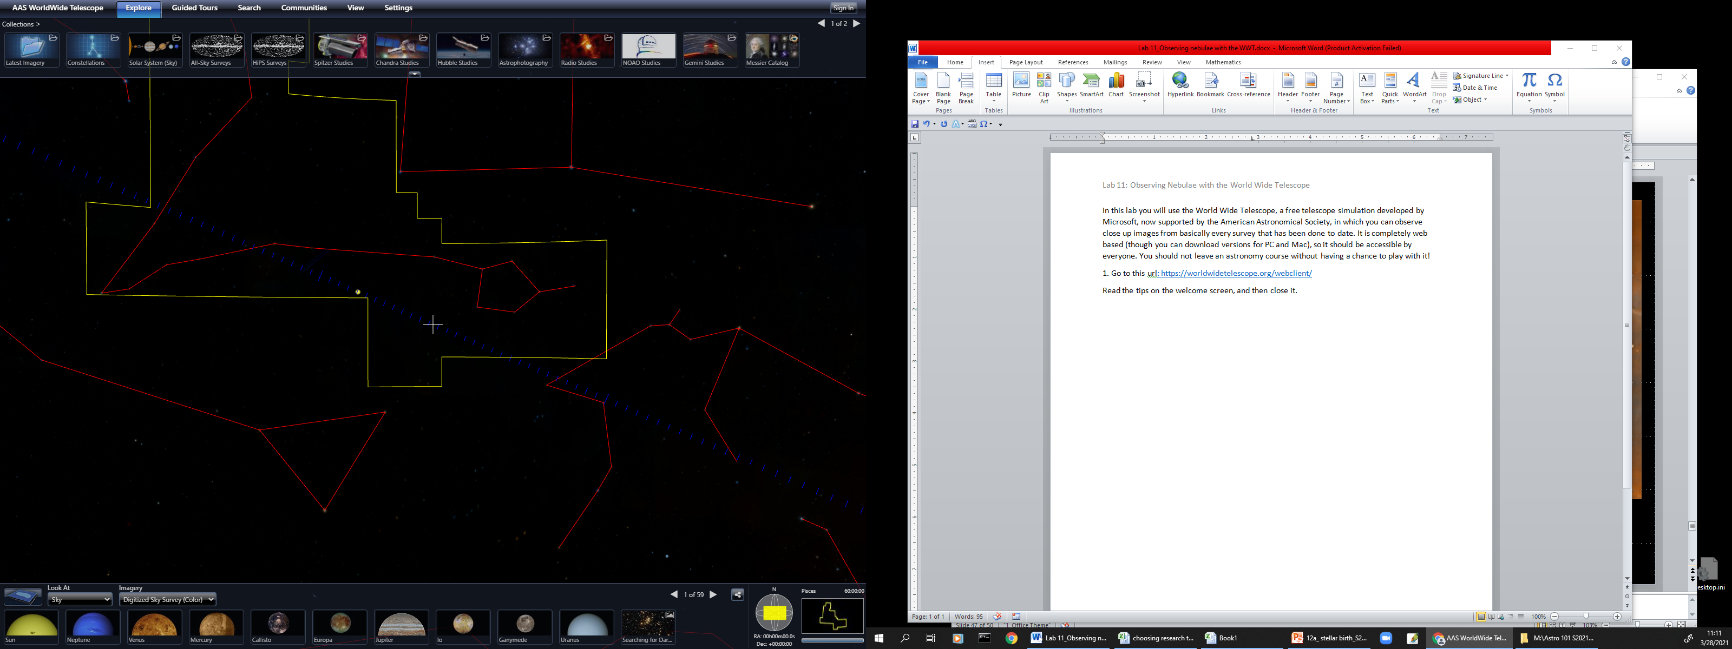
The cross hair in the center of your screen is the center of the field of view of your virtual telescope.
Your opening default view is looking toward the center of the Celestial Sphere (RA 00:00 and Dec. +00.00).
Notice that you have the outlines of all constellations! This is very convenient, as this method of dividing up the sky into arbitrary blocks of ‘real estate’ is how all objects of interest are located, like locating places of interest on Earth by their latitude and longitude. Look at the small finder window in the lower right corner of your screen, and you will find the outline of the total ‘real estate’ for the constellation at the center of your screen, and its name. The default opening constellation is Pisces – the constellation that is currently at the center of the Celestial Sphere.
Enlarged view of the lower right corner of your screen, showing the constellation and RA/Dec location of where your virtual telescope is pointed. The opening screen defaults to RA 00:00, Dec 00.00, in the constellation Pisces.

You can move your field of view by clicking and holding down your mouse (left mouse button on PCs, or dragging your finger on a touch screen) and dragging your mouse around. Try dragging the field of view so that your virtual telescope is pointing towards different constellations. Notice how the little finder map in the lower right corner changes, showing you where your virtual telescope is pointing! (Isn’t this cool?)
Notice that you drag “up” to look “down” and drag “right” to look “left.” Also notice that you are looking around on a SPHERE – you are not dragging on a flat field of view! This is realistic, because when you are looking “out there” you are looking around on the inside surface of an imaginary sphere. So up, down, right, left are only relative to your computer screen.
Notice the blue dashed line across the center of your screen. This is the Ecliptic, the apparent path of the Sun around the sky in one year, or the plane in which the planets orbit the Sun. Drag “left,” moving your crosshairs to the right along the Ecliptic from your opening screen until you see the center of the Milky Way crossing the ecliptic in your field of view.
a) Notice that the Milky Way crosses the Ecliptic at an angle of 60⁰ (measure it on your screen with a protractor, or look it up, to verify!).
b) What two constellations are on either side of the center of the Milky Way?
(See the screen shot on the next page.)

______________________________ and ____________________________________
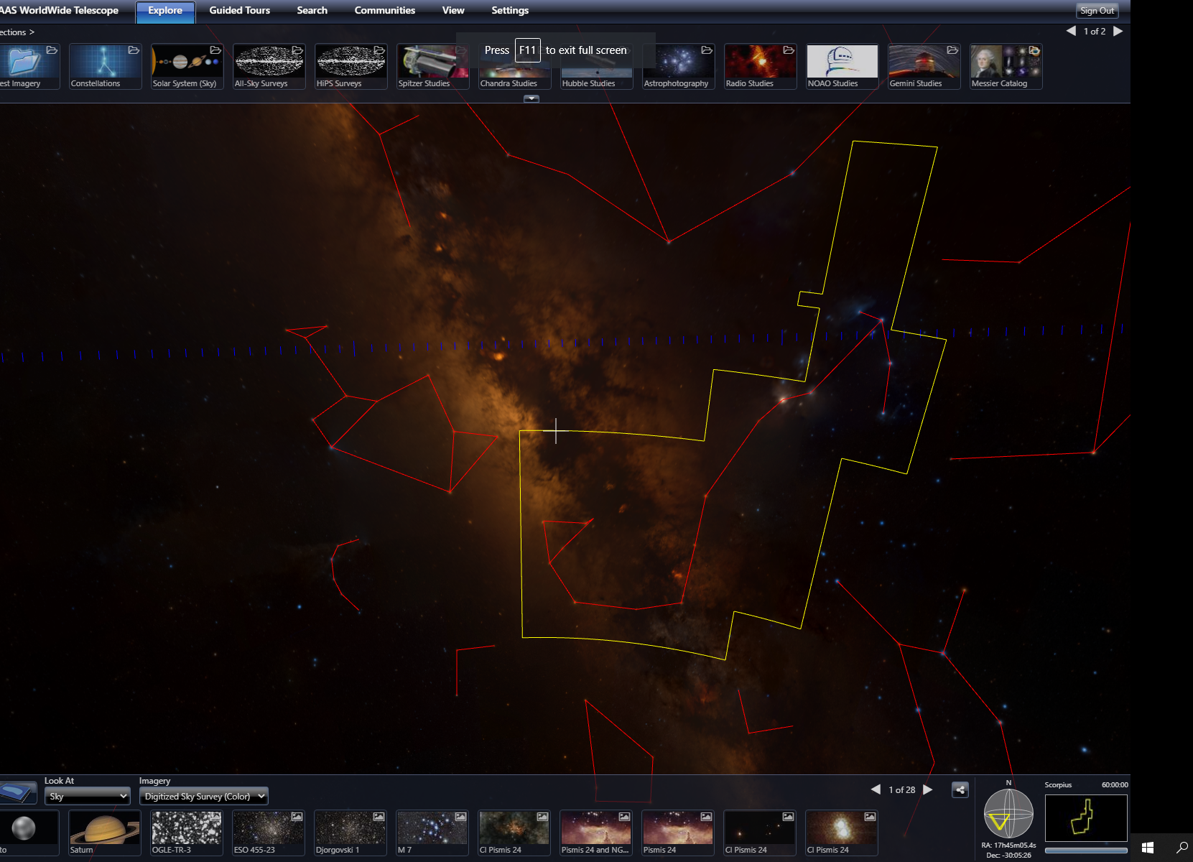
c) Put your cross hairs on the bright object just below the Ecliptic, in the constellation Sagittarius, and zoom in by scrolling the mouse wheel. Wow, cool!!! Look down at the bottom of your screen to see images of this object! It is the Lagoon Nebula!
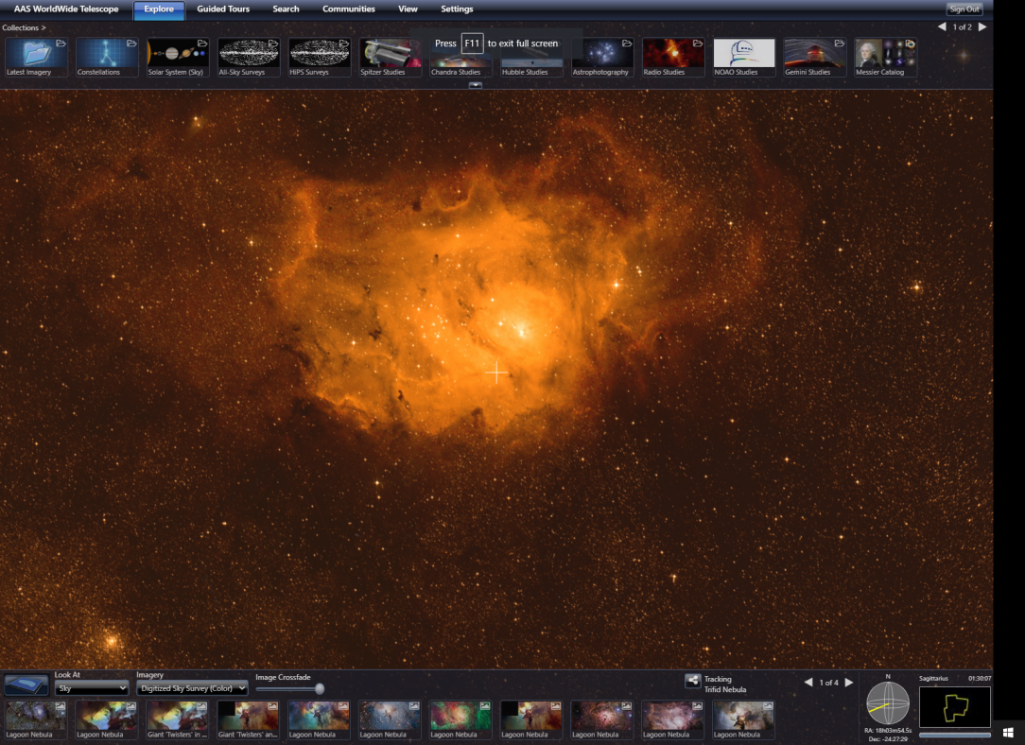
Click on any of the small thumbnail images along the bottom of your screen to zoom into a larger image. Use the mouse wheel to zoom in for a close up.
Right click on any thumbnail to get a drop-down menu of options.
Click on Information, and then choose Wikipedia to read about it! (You can choose one of the sky surveys, but those might give you more information than you want.)
What sort of nebula is the Lagoon Nebula? (Get this info from the Wikipedia link.)

To get back to a wider view, just scroll the mouse wheel back out.

d) Now move your cross hair to the smaller bright blob just above the Lagoon Nebula, close to the Ecliptic. What is this? (Again, see the thumbnail images and name across the bottom of your screen.)

Name: ____________________________________________

Type of Nebula: _______________________________________

e) Now let’s “search” for something. Click the SEARCH button above your field of view and type in “Kepler’s Supernova”. What is this? (Again, see the thumbnail images and name across the top and bottom of your screen.)

Name: ____________________________________________

Type of Nebula: _______________________________________

From the Wikipedia information, is this a Supernova? If so, is it an old one or a recent one?

____________________________________________________________________________

Now you know the basics of using the WWT. Do the second part – finding HII regions in the galactic plane – and then feel free to just play with this software. We will be using it more during the rest of this course.

Part 2: Finding nebulae in the galactic plane with the WWT

Star forming regions can be found mainly in the galactic plane, in the spiral arms. Now we will follow the galactic plane to find some!
1. Drag your crosshairs along the galactic plane to the constellation Serpens, just ‘above’ Sagitarius. Zoom in on the bright blob. What is this?
Name of nebula:

Type of nebula:

What is the dark nebula within it?

2. Now zoom out, and put your cross hairs on the bright blob at the ‘northern’ edge of Sagitarius and zoom in. What is this?
Name of nebula:
Type of nebula:

3. Zoom out again, and follow the galactic plane with your cross hairs, into the constellation Scorpius. (Remember, look at the name in the little finder window at the lower right corner of your screen to see where you are.) You should see several ‘smudges’ – zoom in and find out what they are! As you zoom in, you may find more – what are they?

4. HII star forming regions are located in the spiral arms, along the galactic plane, and that they are often shrouded in dust which makes them invisible to visible light surveys. Keep your crosshairs an object of interest, and look down at the lower menu bar to the dropdown menu labeled Imagery.
Click on the down arrow to see the drop-down menu of all the sky surveys that the WWT contains – a LOT! Choose the 7th one down – the WISE All Sky Infrared survey. With infrared you can see through the dark clouds surrounding the star forming regions that are invisible in the visible light surveys! Wow, what a different view! Move the crosshairs to other objects and describe what you see. Describe three objects.

Number | Name of Nebula (or star cluster) | Type of Nebula (or star cluster | Stars’ spectral classes
1

2

3

